Orange
Green
Yellow
Purple
Brown
Black
Pink
Grey
Blue

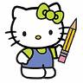 |  | 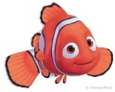 | 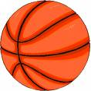 | 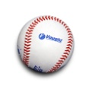

Baseball
Basketball
Hello Kitty
Nemo
Happy Feet

